AWS Trusted Advisor Assistant

Intro:

The AWS Trusted Advisor Assistant revolutionizes how organizations interact with their cloud infrastructure by offering a conversational AI solution that eliminates the complexity of traditional dashboard navigation. This innovative tool allows users to access and act on AWS Trusted Advisor recommendations through natural language queries, providing immediate access to optimization insights across cost, performance, security, service limits, and fault tolerance.
By combining sophisticated natural language processing with real-time data retrieval, the Assistant delivers personalized guidance that draws from both current account data and comprehensive AWS best practices. Users can simply ask questions like "What cost optimization opportunities exist in my account?" and receive instant, actionable insights enhanced with visual representations that make complex infrastructure data readily understandable. This RAG-based solution represents a significant advancement in making cloud optimization more accessible, efficient, and user-friendly for AWS customers of all technical levels.

Solution Overview
AWS Trusted Advisor Assistant is a RAG-based conversational AI solution that transforms how users interact with AWS Trusted Advisor recommendations. By combining natural language processing with real-time data retrieval, this solution empowers customers to optimize their AWS environments through intuitive conversation rather than manual dashboard navigation.
Key Capabilities
The AWS Trusted Advisor Assistant delivers four core capabilities:
Natural Language Query Processing allows users to ask questions about their Trusted Advisor findings in plain English. Instead of navigating complex dashboards, users can simply ask "What cost optimization opportunities exist in my account?" or "Are there any security findings I should address immediately?"
Real-Time Recommendation Fetching ensures users always receive the most current information. The assistant connects directly to Trusted Advisor APIs, retrieving and presenting the latest findings whenever queries are made.

Interactive Dashboard with Visualizations transforms complex Trusted Advisor data into actionable insights. Users gain access to visual representations of their findings across the five Trusted Advisor pillars: Cost Optimization, Performance, Security, Service Limits, and Fault Tolerance.

RAG-Based Contextual Responses leverage Retrieval-Augmented Generation technology to provide responses that combine the latest Trusted Advisor data with comprehensive AWS best practices. This ensures answers are both accurate and educational.

Business Value
Reduced Time-to-Resolution: By eliminating the need to navigate through dashboards and documentation, the Assistant enables faster identification and remediation of potential issues.
Enhanced Accessibility: Technical and non-technical users alike can access Trusted Advisor insights through natural conversation, democratizing access to optimization opportunities.
Improved Resource Optimization: The solution's proactive approach to surfacing recommendations leads to better optimized AWS environments and reduced wasted spend.
Educational Value: Contextual responses help users understand not just what to fix but why issues matter and how to prevent similar issues in the future.

Architecture Diagram

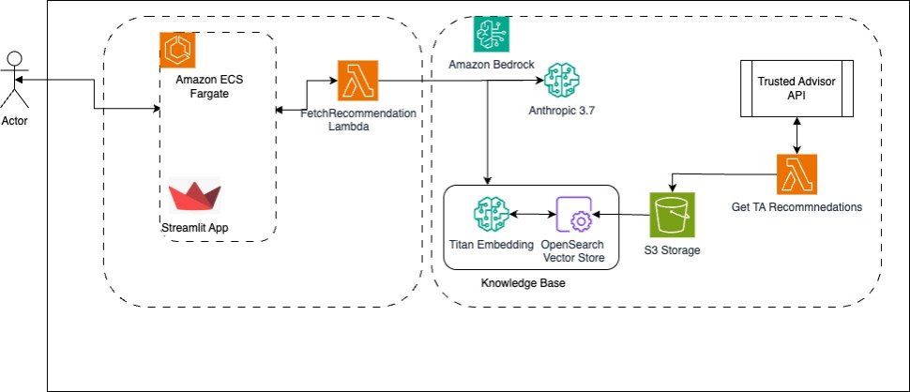
Amazon ECS Fargate: The process begins with an Actor (user) who interacts with a Streamlit application hosted on Amazon ECS Fargate, providing a serverless container environment.

AWS Lambda Fetch TA Recommendation Lambda: When the user makes a request, it triggers the FetchRecommendation Lambda function, which processes the initial query of the user to fetch the current TA recommndations.

Amazon Bedrock: The system then passes this information to Amazon Bedrock, which interfaces with Anthropic 3.7 Sonnet, a large language model that handles natural language understanding and generation using Retrieval Augment and Generation to answer the contextual queries from user related to trusted advisor recommendations.

AWS Lambda Get TA Recommendations: When recommendations are needed, the "Get TA Recommendations" Lambda function calls the Trusted Advisor API, which returns relevant recommendations.

AWS Trusted Advisor Assistant - Implementation Guide

Overview
The AWS Trusted Advisor Assistant is an intelligent dashboard that enhances AWS Trusted Advisor recommendations with AI-powered insights using Amazon Bedrock. This cloud-native application provides conversational AI capabilities for better understanding and acting on AWS infrastructure recommendations.

Architecture Overview
Core Components:
- Frontend: Streamlit web application with interactive dashboard
- Backend: Python service integrating AWS Support API and Amazon Bedrock
- Infrastructure: AWS ECS Fargate with Application Load Balancer
- Security: AWS Secrets Manager for credential management
- AI Enhancement: Amazon Bedrock with Claude 3 Sonnet model
Deployment Flow:

Internet → ALB → ECS Fargate → AWS Services (Support API, Bedrock, Secrets Manager)

---
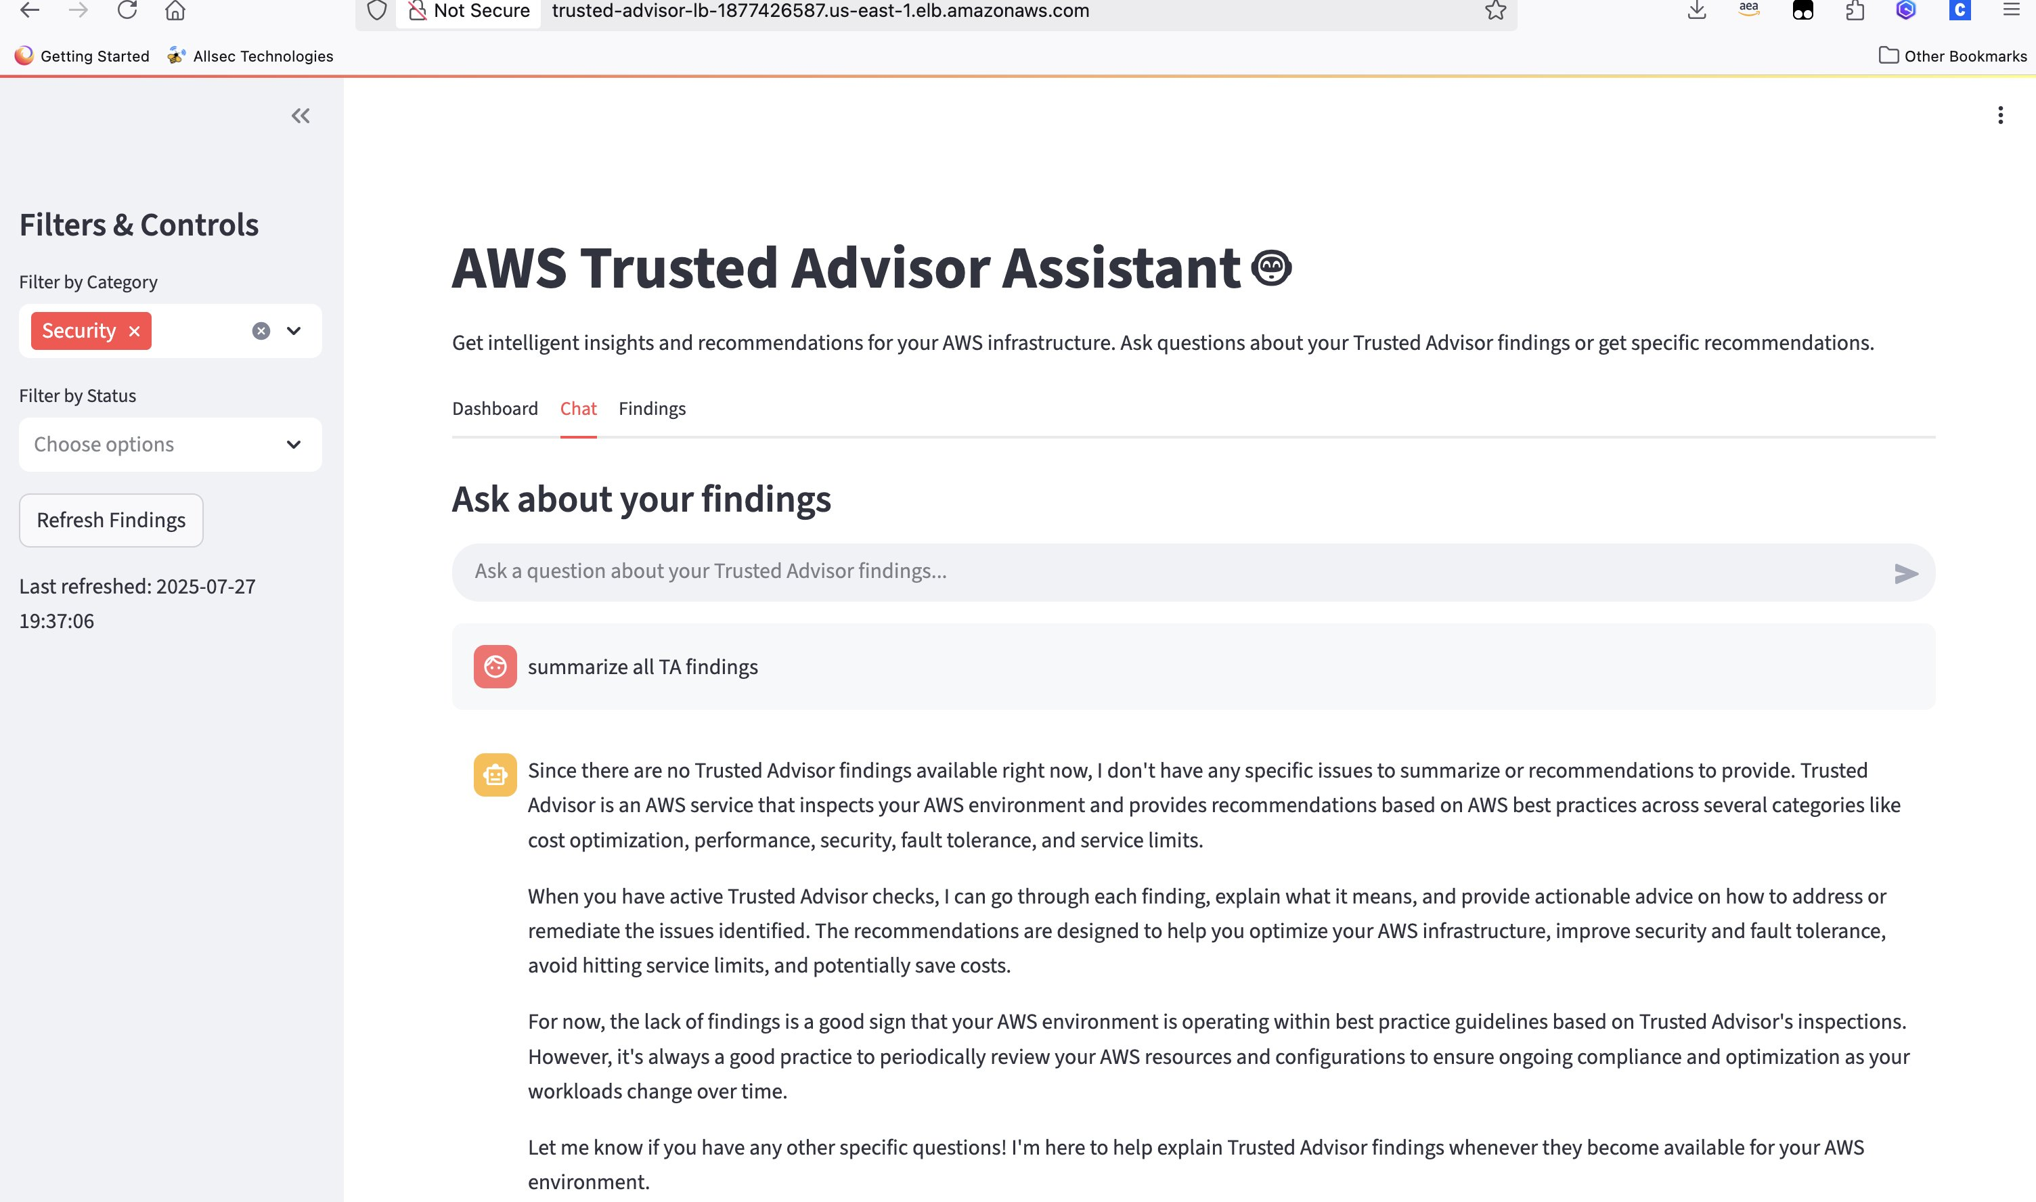
Implementation completed successfully! The AWS Trusted Advisor Assistant is now ready to provide AI-enhanced insights for your AWS infrastructure recommendations.
## 📁 Project Files Structure

TAAssistant/
├── app.py # Main Streamlit application
├── TAEnhancer.py # Core Trusted Advisor enhancement logic
├── script.sh # Docker build and ECR push script
├── deploy-complete-with-secrets.sh # Enhanced deployment with Secrets Manager
├── test_enhancer.py # Testing script for TAEnhancer
├── TAAssistantCFN_Complete.yml # Complete CloudFormation template with Secrets Manager
├── ecr-only.yml # ECR repository CloudFormation
├── trusted-advisor-policy.json # IAM policy for the application

